Bachelor projekt am Bodensee
Groundwater fluxes to Steißlinger See
Lakes can be very sensitive to changes in water sources and nutrient fluxes. Groundwater is an often ignored part of lakes water balance because it cannot be seen and is easily forgotten. However, it can be a very important part of lakes water balance and for nutrient fluxes. In this work we will use the groundwater tracer Radon to quantify groundwater fluxes to the Steißlinger See, near the Bodensee. This lake is currently of interest for the Landesanstalt für Umwelt, Messungen und Naturschutz Baden-Württemberg due to its nutrient status and unknown water sources. We will also study the chemistry of the lake to help interpret the importance of the groundwater for the lake’s chemical balance and better understand chemical cycling. It is known that the Steißlinger See has springs entering the lake, but it is still unclear how much water they deliver, at which depth they enter the lake, and how they influence the lake’s geochemistry.

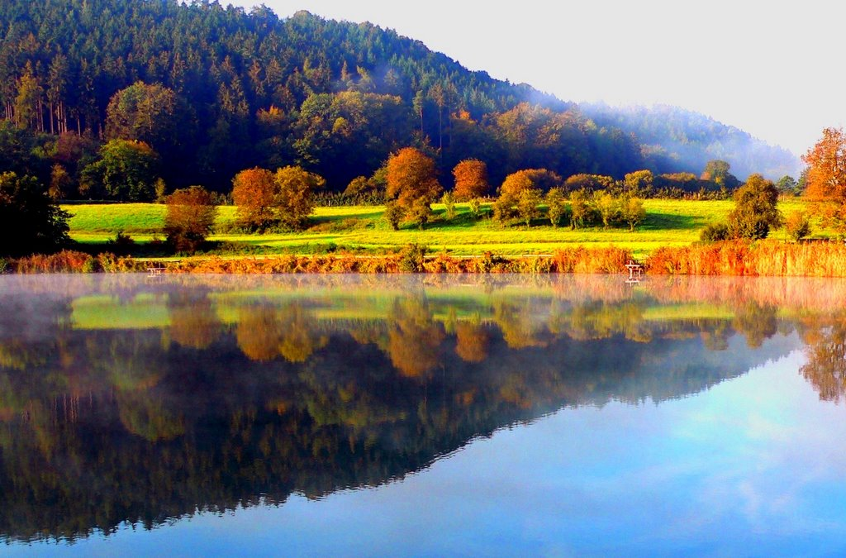

If you are interested in this project, or would just like to know more, please see me in the Limnology Station or send an email to Benjamin-silas.gilfedder@uni-bayreuth.de

Ben Gilfedder

